Tech Note: Robot Communication ABB EIP

1 Overview 2
1.1 Scope 2
1.2 Needed Hardware 2
1.3 Needed Software 2
2 EtherNet/IP Communications 2
2.1 In-Sight Setup 2
2.2 EIP Setup 2
2.3 Robot Controller Setup 3
2.3.1 Define a new I/O Unit type with the following parameters: 3
2.3.2 Define a new EIO unit with the following parameters: 3
2.3.3 Define new Inputs: 4
2.3.4 Define new Outputs: 4
2.4 Robot Controller RAPID code 5
2.5 Job Setup 6
2.6 Calibration 7
2.7 Part Training 7

Overview

Scope
The purpose of this document is to outline the steps needed to connect and transfer data from a Cognex In-Sight Sensor to an ABB Robot Controller. In all of the setups outlined, the robot controller will be the device controlling the acquisition and transfer of data. In general the robot controller, with the use of In-Sight EIP, will trigger the sensor to acquire and process an image and then the robot controller will request specific X, Y, and angle data from the sensor. EIP will be used to trigger the camera and send data to the robot. 32bit digital inputs will be used to transfer the 2D part location. Since floating point numbers cannot be sent over digital input the numbers will be multiplied by 1000 on the In-Sight side, and divided by 1000 on the robot side.

Needed Hardware
In-Sight Sensor (models 1400 or 5x00)
Ethernet Cable
Computer
ABB Robot Controller (IRC5)

Needed Software
ABB RAPID programming language
PC Interface (Recommended for Ethernet communications but not required)
841-1 EtherNet/IP M/S
905-1 EtherNet/IP port
In-Sight Explorer 4.0 or higher

EtherNet/IP Communications

In-Sight Setup
- Make sure In-Sight Explorer version 4.0 or higher is installed
- Make sure the sensors firmware is version 4.0 of higher

EIP Setup
- Select Sensor | Network Settings
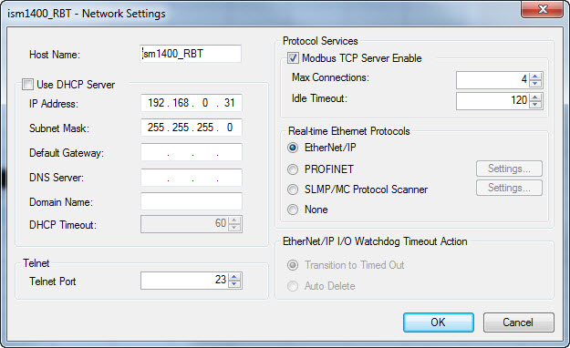

Make sure that the EtherNet/IP radio button is selected

Robot Controller Setup

Define a new I/O Unit type with the following parameters:
- Name "ISM_EIP"
- BusType "ENIP"
- VendorName "Cognex"
- ProductName "ISM"
- VendorId 678
- DeviceType 100
- ProductCode 260
- OutputAssembly 21
- InputAssembly 11
- OutputSize 64
- InputSize 64

Define a new EIO unit with the following parameters:
- Name "ISM_1400"
- UnitType "ISM_EIP"
- Bus "EtherNetIP1"
- Address "192.168.0.31"

Define new Inputs:
Name | Signal Type | Signal Label | Unit Map
isDI_Trig_Ready | DI | Trigger Ready | 0
isDI_Trig_Ack | DI | Trigger Ack | 1
isDI_Acquiring | DI | Acquiring | 2
isDI_Miss_Ack | DI | Missed Acquisition | 3
isGI_Offline_Reason | GI | Offline Reason | 4-6
isDI_Online | DI | Online | 7
isDI_Inspecting | DI | Inspecting | 8
isDI_Inspect_Comp | DI | Inspection Completed | 9
isDI_Buffer_Overrun | DI | Results Buffer Overrun | 10
isDI_Results_Valid | DI | Results Valid | 11
isDI_Job_Loading | DI | Job Loading | 12
isDI_Load_Comp | DI | Job Load Completed | 13
isDI_Load_Fail | DI | Job Load Failed | 14
isDI_Reserved | DI | Reserved | 15
isDI_AcquisitionID | GI | Ack ID | 16-31
isDI_InspectionID | GI | Inspection ID | 32-47
isDI_InspectionResult | GI | Inspection Result | 48-63
isDI_ResultData0 | GI | User Data Input 0 | 64-95
isDI_ResultData1 | GI | User Data Input 1 | 96-127
isDI_ResultData2 | GI | User Data Input 2 | 128-159

Define new Outputs:

Name | Signal Type | Signal Label | Unit Map
isDO_Trig_Enable | DO | Trigger Enable | 0
isDO_Trigger | DO | Trigger | 1
isDO_Results_Enable | DO | Buffer Results Enable | 2
isDO_Results_Ack | DO | Inspection Results Ack | 3
 | DO | Reserved | 4
 | DO | Reserved | 5
 | DO | Reserved | 6
isDO_Set_Offline | DO | Set Offline | 7
isDO_SE0 | DO | Soft Event 0 | 8
isDO_SE1 | DO | Soft Event 1 | 9
isDO_SE2 | DO | Soft Event 2 | 10
isDO_SE3 | DO | Soft Event 3 | 11
isDO_SE4 | DO | Soft Event 4 | 12
isDO_SE5 | DO | Soft Event 5 | 13
isDO_SE6 | DO | Soft Event 6 | 14
isDO_SE7 | DO | Soft Event 7 | 15
isDO_Reserved | GO | Reserved | 16-31
isDO_UserData_000 | GO | User Data 0 | 32-39
isDO_UserData_001 | GO | User Data 1 | 40-47

Robot Controller RAPID code
%%%
VERSION:1
LANGUAGE:ENGLISH
%%%

MODULE IS_EIP
! DATA DECLARATIONS
PERS tooldata tVision:=[TRUE,[[0,0,0],[0,0,0,1]],[5,[1,1,1],[1,0,0,0],0,0,0]];
PERS wobjdata wFixture:=[FALSE,TRUE,"",[[0,0,0],[1,0,0,0]],[[0,0,0],[1,0,0,0]]];
CONST robtarget pHome:=[[0,0,0],[0,0,0,1],[-2,0,1,0],[9E+09,9E+09,9E+09,9E+09,9E+09,9E+09]];
CONST robtarget pGrip:=[[0,0,0],[0,0,0,1],[-2,0,-1,0],[9E+09,9E+09,9E+09,9E+09,9E+09,9E+09]];
CONST robtarget x_1:=[[100,75.38,-41.04],[5.3105E-05,-0.701712,0.712461,-2.84491E-06],[0,0,-1,0],[9E+09,9E+09,9E+09,9E+09,9E+09,9E+09]];
CONST robtarget x_2:=[[300,76.11,-27.69],[1.90082E-05,-0.701723,0.71245,2.73112E-05],[0,0,-1,0],[9E+09,9E+09,9E+09,9E+09,9E+09,9E+09]];
CONST robtarget y_1:=[[100.24,-1549.38,-40.95],[1.90504E-05,-0.701721,0.712452,7.65176E-05],[-1,0,-2,0],[9E+09,9E+09,9E+09,9E+09,9E+09,9E+09]];

PROC Main()
MoveL pHome,v1000,fine,tVision;
Trigger_IS;
SetOframe;
MoveL Offs(pGrip,0,0,100),v500,z1,tVision\WObj:=wFixture;
MoveL pGrip,v100,fine,tVision\WObj:=wFixture;
!Close Gripper...
MoveL Offs(pGrip,0,0,100),v500,z1,tVision\WObj:=wFixture;
!...
MoveL pHome,v1000,fine,tVision;
ENDPROC

PROC SetOframe()
!Reset object frame
wFixture.oframe:=[[0,0,0],[1,0,0,0]];
! assigne measurement data
wFixture.oframe.trans.x:=DnumToNum(GInputDnum(isGI_ResultData0)/1000);
wFixture.oframe.trans.y:=DnumToNum(GInputDnum(isGI_ResultData1)/1000);
wFixture.oframe.rot:=OrientZYX(DnumToNum(GInputDnum(isGI_ResultData2)/1000),0,0);
ENDPROC

PROC TeachWobjwFixture()
! For vision work object
MoveL Offs(x_1,0,0,50),v400,z1,tVision;
MoveL x_1,v50,fine,tVision;
TPWrite "Pos x 1";
Break;
MoveL Offs(x_1,0,0,50),v400,z1,tVision;
MoveL Offs(x_2,0,0,50),v400,z1,tVision;
MoveL x_2,v50,fine,tVision;
TPWrite "Pos x 2";
Break;
MoveL Offs(x_2,0,0,50),v400,z1,tVision;
MoveL Offs(y_1,0,0,50),v400,z1,tVision;
MoveL y_1,v50,fine,tVision;
TPWrite "Pos y 1";
Break;
MoveL Offs(y_1,0,0,50),v100,z1,tVision;
wFixture.uframe:=DefFrame(x_1,x_2,y_1);
ENDPROC

PROC Trigger_IS()
SETDO isDO_Trig_Enable,1;
WAITDI isDI_Trig_Ready,1;
SETDO isDO_Trigger,1;
WAITDI isDI_Trig_Ack,1;
SETDO isDO_Trigger,0;
WAITDI isDI_Acquiring,0;
WAITDI isDI_Inspect_Comp,1;
ENDPROC

ENDMODULE

Job Setup
With a New Job perform the following steps:
- Set the following A0 Image cell properties (double-click cell A0):
  - Trigger = External
  - Manual = Checked
- In cell A2 type FindPattern( at this point the property sheet for FindPattern should popup, click OK
- Insert Snippet “ABB_EIP”:
  - Select cell A4
  - If the Tool Palette isn’t visible; select View | Tool Palette
  - From the Snippets tab find and double-click
Communications | Robots | ABB_EIP
- Define the coordinate cell references:
  - : Double-click C6, double-click C2,
  - Y: Double-click D6, double-click D2
  - Angle: Double-click E6, double-click E2
- Press the Manual Trigger icon a few times to confirm that the FindPatterns data is changing.
- Save the job
- Turn the sensor Online

Calibration
Make sure to setup the robot work object to match the direction of the vision X and Y axis as shown below. Use the robot program TeachWobjwFixture program to modify the 3 positions and create a coordinate frame that matches the calibration grid direction.
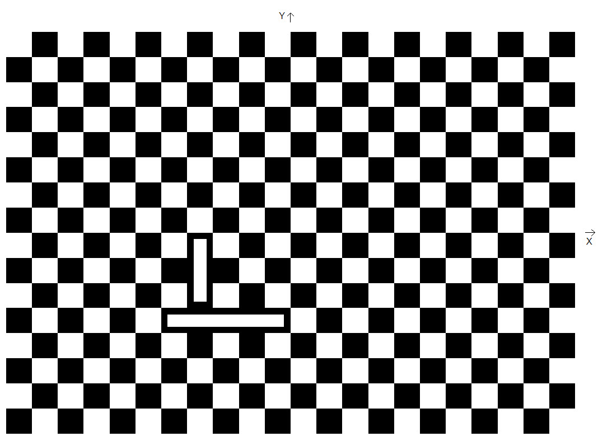

Part Training
Train the Pattern using the FindPattern Tool
Request the position data from the camera in robot coordinates
This data will be input into the work object Object frame offset, subsequent parts will overwrite this data with the new location of the part.
Move the robot to the pickup position and modify that location

